Key

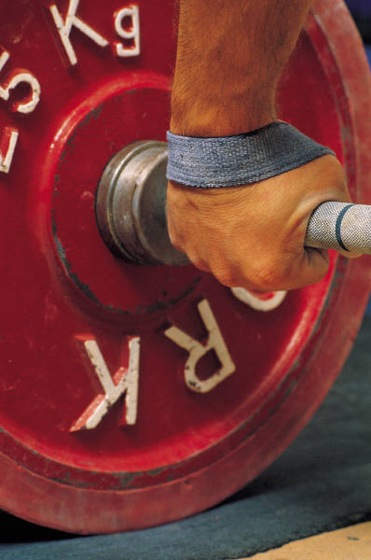 Lifting
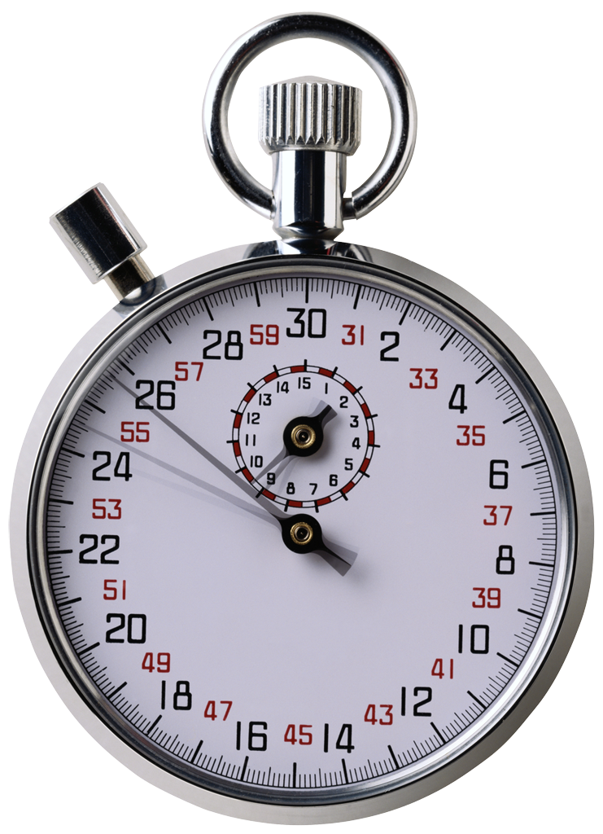 Aerobic conditioning
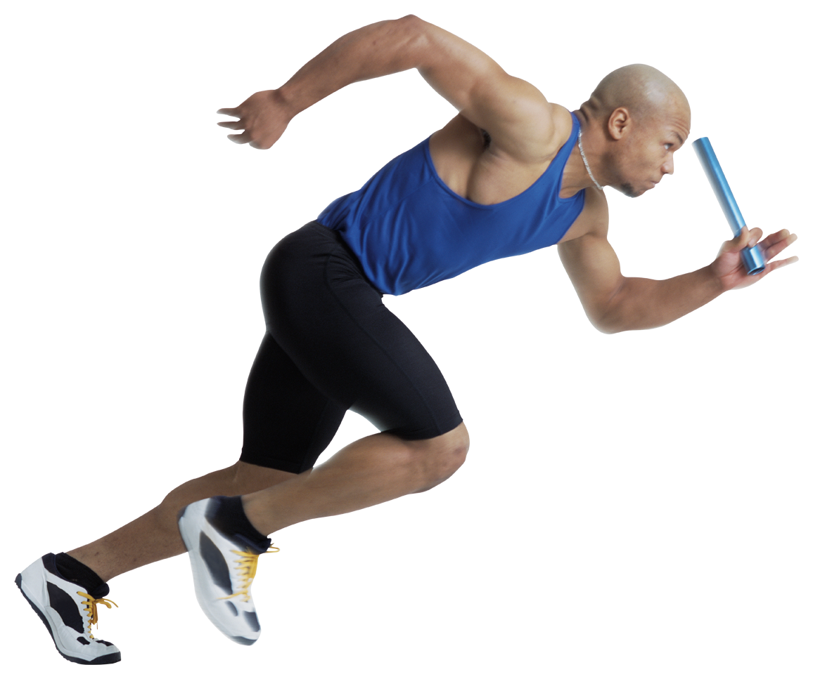SAQ Conditioning
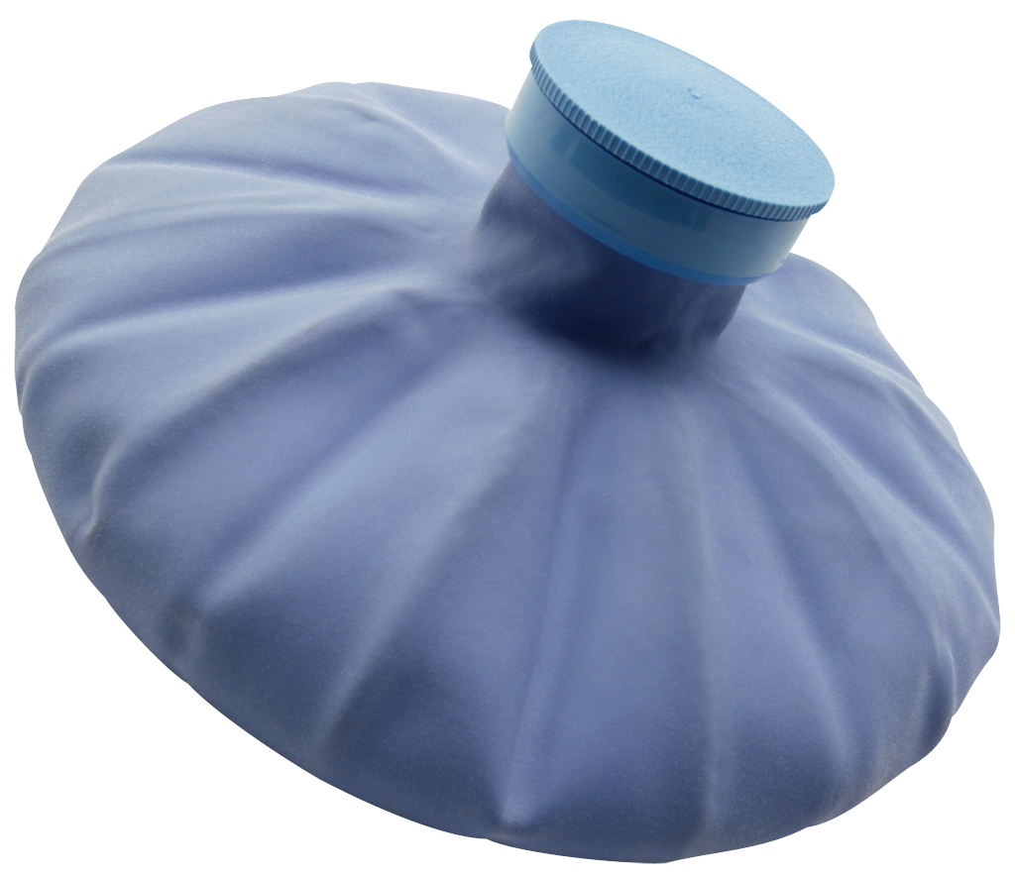 Recovery
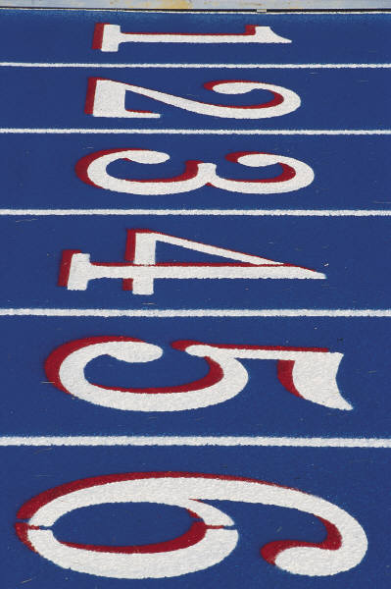
Hill Conditioning

May 2013 – UMRFC Ann Arbor 7’s
Mon 6  Pre-Conditioning  Day 1 | Tue 7  Rest | Wed 8  Aerobic  Conditioning 1 | Thu 9  Pre-Conditioning  Day 2 + Touch 6-8pm | Fri 10  Rest | Sat 11  Aerobic Conditioning 2 | Sun 12  Rest
Mon 13  Pre-Conditioning  Day 1 | Tue 14  Touch 6-8pm | Wed 15  Aerobic Conditioning 1(am) + 7’s Practice 7-8pm | Thu 16  Pre-Conditioning  Day 2 + Touch 6-8pm | Fri 17  Rest | Sat 18  Aerobic Conditioning 2 | Sun 19  Rest
Mon 20  Strength Endurance Day 1 | Tue 21  Touch 6-7:30pm  Conditioning 7:30-8pm | Wed 22  7’s practice 7-8pm  Strength Endurance Day 2 | Thu 23  Touch 6-7:30pm  Conditioning 7:30-8pm | Fri 24  Rest- Travel to Tournament | Sat 25  Larrimer Cup 7’s Tournament - Ohio | Sun 26  Rest
Mon 27  Strength Endurance Day 1 | Tue 28  Touch 6-7:30pm  Conditioning 7:30-8pm | Wed 29  7’s practice 7-8pm  Strength Endurance Day 2 | Thu 30  Touch 6-7:30pm  Conditioning 7:30-8pm | Fri 31  Strength Endurance Day 3

June 2013 – UMRFC Ann Arbor 7’s
 |  |  |  |  | Sat 1  Stairs/Campus/Arb Run | Sun 2  Rest
Mon 3  7’s Hypertophy | Tues 4  Touch 6-7:30pm  Conditioning 7:30-8pm | Wed 5  7’s practice 7-8pm  7’s Strength | Thurs 6  Touch 6-7:30pm  Conditioning 7:30-8pm | Fri 7  7’s Power | Sat 8  Stairs/Campus/Arb Run | Sun 9  Rest
Mon 10  7’s Hypertophy | Tues 11  Touch 6-7:30pm  Conditioning 7:30-8pm | Wed 12  7’s practice 6-7pm  7’s Strength | Thurs 13  Touch 6-7:30pm  Conditioning 7:30-8pm | Fri 14  7’s Power | Sat 15  Stairs/Campus/Arb Run | Sun 16  Rest
Mon 17  7’s Hypertophy | Tues 18  Touch 6-7:30pm  Conditioning 7:30-8pm | Wed 19  7’s practice 6-7pm  7’s Strength | Thurs 20  Touch 6-7:30pm  Recovery 7:30-8pm | Fri 21  Rest | Sat 22  Meijer State Games – Grand Rapids | Sun 23  Rest
Mon 24  Aerobic Conditioning 4 | Tues 25  Touch 6-7:30pm  Conditioning 7:30-8pm | Wed 26  7’s practice 6-7pm  Aerobic Conditioning 4 | Thurs 27  Touch 6-7:30pm  Conditioning 7:30-8pm | Fri 28  Aerobic Conditioning 4 | Sat 29  Active Rest | Sun 30  Active Rest

